From: http://www.rollingstone.com/politics/features/taibbi-how-did-russiagate-start-w482262

How Did Russiagate Start?
Amid the chaos of James Comey's firing, new questions about the timeline of his fateful investigation
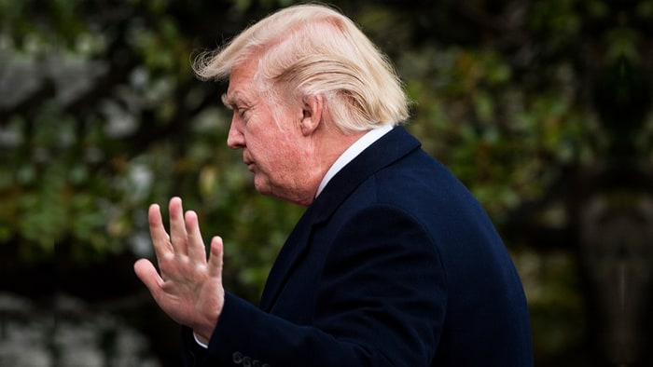Uncertainty about the Trump-Russia collusion investigation has led to widespread public terror, mass media hysteria and excess, and possibly even panic in the White House itself. Pete Marovich-Pool/Getty
By Matt Taibbi
May 15, 2017
5 days ago
Former Director of National Intelligence James Clapper appeared on This Week Sunday, and said some head-scratching things.

Clapper back in March told Meet the Press that when he issued a January 6th multiagency intelligence community assessment about Russian interference in the election, the report didn't include evidence of collusion between the Trump campaign and Russia, essentially saying he hadn't been aware of any such evidence up through January 20th, his last day in office.
On Sunday, he said that didn't necessarily mean there was no such evidence, because sometimes he left it up to agency chiefs like former FBI Director James Comey to inform him about certain things.
"I left it to the judgment [of] Director Comey," Clapper said, "to decide whether, when and what to tell me about counterintelligence investigations."
Clapper said something similar when he testified before the Senate Judiciary Committee last Monday. In prepared remarks, he essentially said that there was nothing odd about his not being informed about the existence of an FBI counterintelligence investigation involving Donald Trump's campaign.
Speaking generally, Clapper seemed to imply that the Trump-Russia-collusion scandal, the thing colloquially known as #Russiagate all over the world now, may have originated in information gleaned by the intelligence community, who in turn may have tipped off the FBI.
"When the intelligence community obtains information suggesting that a U.S. person is acting on behalf of a foreign power," he said, "the standard procedure is to share that information with the lead investigatory body, which of course is the FBI."
He went on, explaining that in such a situation, it wouldn't be unusual for the DNI to not be informed about an FBI counterintelligence investigation.
"Given its sensitivity," he said, "even the existence of a counterintelligence investigation's closely held, including at the highest levels."
In his Senate testimony, Clapper went out of his way to say this didn't contradict his earlier statements. But if he's not contradicting himself, he's certainly added a layer of confusion to what is already the most confusing political scandal ever.
Back on March 5th, when Clapper gave that interview to Chuck Todd on Meet the Press, he sounded definitive on a number of counts.
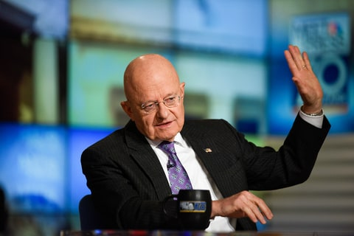James Clapper on 'Meet the Press' March 5th William B. Plowman/NBC/Getty
Todd for instance asked Clapper if he would know if the FBI had a FISA court order for surveillance. Clapper answered unequivocally: "Yes."
Clapper made it clear that he would have known if there were any kind of surveillance authority against "the president elect at the time, or as a candidate, or against his campaign."
Todd realized this was an important question and re-asked it, to make sure Clapper heard it right.
"You would be told this?" he asked.
"I would know that," Clapper answered.
Todd asked again: Are you sure? Can you confirm or deny that a FISA warrant exists?
"I can deny it," Clapper said flatly.
It wasn't until the fourth time Todd asked the question that Clapper finally added the caveat, "Not to my knowledge."
Even so, there was no way to listen to the March 5th interview and not come away feeling like Clapper believed he would have known of the existence of a FISA warrant, or of any indications of collusion between the Trump campaign and Russia, had they existed up until the time he left office on January 20th of this year.
Todd went out of his way to hammer at the question of whether or not he knew of any evidence of collusion. Clapper again said, "Not to my knowledge." Here Todd appropriately pressed him: If it did exist, would you know?
To this, Clapper merely answered, "This could have unfolded or become available in the time since I left the government."
That's not an unequivocal "yes," but it's close. There's no way to compare Clapper's statements on March 5th to his interviews last week and not feel that something significant changed between then and now.
Clapper's statements seem even stranger in light of James Comey's own testimony in the House on March 20th.
In that appearance, Comey – who by then had dropped his bombshell about the existence of an investigation into Trump campaign figures – was asked by New York Republican Elise Stefanik when he notified the DNI about his inquiry.
"Good question," Comey said. "Obviously, the Department of Justice has been aware of it all along. The DNI, I don't know what the DNI's knowledge of it was, because we didn't have a DNI – until Mr. Coats took office and I briefed him his first morning."
Comey was saying that he hadn't briefed the DNI because between January 20th, when Clapper left office, and March 16th, when former Indiana senator and now Trump appointee Dan Coats took office, the DNI position was unfilled.
But Comey had said the counterintelligence investigation dated back to July, when he was FBI director under a Democratic president. So what happened between July and January?
If Comey felt the existence of his investigation was so important that he he had to disclose it to DNI Coats on Coats' first day in office, why didn't he feel the same need to disclose the existence of an investigation to Clapper at any time between July and January?
Furthermore, how could the FBI participate in a joint assessment about Russian efforts to meddle in American elections and not tell Clapper and the other intelligence chiefs about what would seemingly be a highly germane counterintelligence investigation in that direction?
Again, prior to last week, Clapper had said he would know if there was a FISA warrant issued on this matter. But then on April 11th, law enforcement and government officials leaked – anonymously, as has been the case throughout most of this story – that the FBI had obtained a FISA warrant for surveillance of Trump associate Carter Page.
So what's going on here? In talking to people on the Hill last week, I heard a number of theories.
One interpretation is that the FBI, concerned about operational security, conducted a secret investigation during the last months of Barack Obama's presidency without informing the likes of Clapper and other agency chiefs.
But why hide your investigation in Obama's administration, only to tell superiors about it under Trump? Why keep a secret from Clapper and not Coats? Moreover, why hide it from the voting public before the election, but announce it on live TV on March 20th?
Another interpretation is that Clapper was simply not telling the whole truth, either on March 20th or last week. In this version of events, he knew of the FBI investigation all along. More than one person I spoke with found it implausible that Clapper could have been ignorant of any investigation, especially following the issuance of the reported FISA warrant against Page.
But the context of these interviews still makes Clapper dissembling in his March interview a strange and unlikely possibility. Clapper has not been in the habit of doing Trump political favors this season. And if indeed it's standard practice for a DNI to not know what counterintelligence operations the FBI might be up to, it would have made a lot more sense for Clapper to say that on Meet the Press on March 5th.
Instead, he [“]did Trump a solid[“] by stating unequivocally that there were no FISA warrants out, and that he would have known if there were, adding he had seen no evidence of collusion. Why?
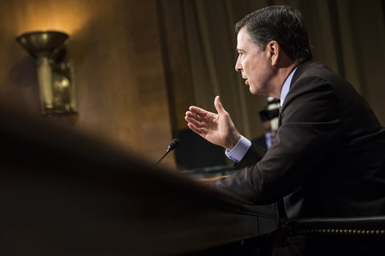James Comey Samuel Corum/Anadolu Agency/Getty
When James Comey was fired last week, I didn't know what to think, because so much of this story is still hidden from view.
Certainly firing an FBI director who has announced the existence of an investigation targeting your campaign is going to be improper in almost every case. And in his post-firing rants about tapes and loyalty, President Trump validated every criticism of him as an impetuous, unstable, unfit executive who additionally is ignorant of the law and lunges for authoritarian solutions in a crisis.
But it's our job in the media to be bothered by little details, and the strange timeline of the Trump-Russia investigation qualifies as a conspicuous loose end.
What exactly is the FBI investigating? Why was it kept secret from other intelligence chiefs, if that's what happened? That matters, if we're trying to gauge what happened last week.
Is it a FARA (Foreign Agent Registration Act) case involving former National Security Adviser Michael Flynn or a lower-level knucklehead like Carter Page?
Since FARA is violated more or less daily in Washington and largely ignored by authorities unless it involves someone without political connections (an awful lot of important people in Washington who appear to be making fortunes lobbying for foreign countries are merely engaged in "litigation support," if you ask them), it would be somewhat anticlimactic to find out that this was the alleged crime underlying our current white-hot constitutional crisis.
Is it something more serious than a FARA case, like money-laundering for instance, involving someone higher up in the Trump campaign? That would indeed be disturbing, and it would surely be improper – possibly even impeachable, depending upon what exactly happened behind the scenes – for Trump to get in the way of such a case playing itself out.
But even a case like that would be very different from espionage and treason. Gutting a money-laundering case involving a campaign staffer would be more like garden-variety corruption than the cloak-and-dagger nightmares currently consuming the popular imagination.
However, let's say the FBI is actually investigating collusion between the Trump campaign and the Russian state. That's the most serious possibility, and the one exciting so much public dread.
If it's that, what's at the heart of that case? Why can't we be told what's going on? Operational secrecy would be a believable excuse, were it not for the fact that so much else has been leaked. Intelligence sources even appeared to give up their ability to capture Russian officials celebrating Trump's election win. If something like that can be leaked, and if even foreign governments can be told about "leverages of pressure" Russia allegedly has on Trump, it stands to reason that the American public should have heard what's behind the Trump-Russia investigation by now.
Trump easily could have committed some disqualifying act in response to this scandal. The worry about that is why we've always needed an independent investigation.
Such an investigation into Trump's campaign might very well uncover a range of improprieties and shady dealings by some of the campaign "associates" who've figured into news reports. This wouldn't be surprising, I don't think, even to some of the people in the White House.
But when it comes to the collusion investigation, there are serious questions. A lot of our civil liberties protections and rules of press ethics are designed to prevent exactly this situation, in which a person lingers for extended periods of time under public suspicion without being aware of the exact nature, or origin, of the accusations.
It's why liberal thinkers have traditionally abhorred secret courts, secret surveillance and secret evidence, and in the past would have reflexively discouraged the news media from printing the unverified or unverifiable charges emanating from such secret sources. But because it's Donald Trump, no one seems to care.
We should care. The uncertainty has led to widespread public terror, mass media hysteria and excess, and possibly even panic in the White House itself, where, who knows, Trump may even have risked military confrontation with Russia in an effort to shake the collusion accusations. All of this is exacerbated by the constant stream of leaks and hints at mother lodes of evidence that are just around the corner. It's quite literally driving the country crazy.
The public deserves to know what's going on. It deserved to know before the election, it deserved to know before the inauguration, and it deserves to know now.

